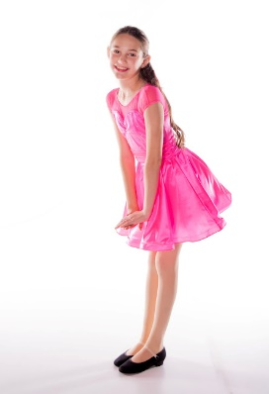
Portrait Week

We have had lots of requests for this in the past, that is why we are so excited to bring you our first ever Portraits Week for School Showcase. Ms. Holly and Ms. Christine got certified through Dance Photo Pro to create beautiful portrait dance photos at a great price for our CDT families.

- April 10th- 15th (that’s the week after Spring Break!) we will be using a portion of class time to take portraits of your dancer and a group picture of the class. Unless told otherwise by your teacher, please have your hair slicked back in a middle part, low bun. Wear class attire as we will be having some class and practice for your piece, but bring your costume and get ready to pose like a super star! Make sure you have the correct shoes on this day.
- April 17th-22nd Proofs will be available for viewing in the CDT offices and available for purchase at a discounted rate ($11 per image, $45 for all images) You get all rights to the images. You will not be forced to buy any prints or packages you don’t necessarily need. Yeah, it’s a crazy good deal for our awesome dance families.
- April 23rd- May 6th Proofs will be available online and can be purchased at their regular price ($13 per image, $55 for all images) Still, a great deal.
- Families will be able to use these photos in program advertisements to savor the memories for years to come. Advertisements are due May 5th. (not available for Mini School Showcase)
- If you are not able to participate in School Showcase we can still get some photos of your dancer in class attire. Such photos are still great memories of this year in dance!
Advertisements for Programs School Showcase 2023

Promote your business or celebrate a dancer in CDT’s program advertisements 2022-2023. Plus, THIS year we will have portrait photography of all our dancers available for purchase by April 22nd. Purchased photos may used in School Showcase advertisements. We are so excited to show off our dancers in their costumes in the program!
Programs are provided to all attendees at the School Showcase. They are thoroughly enjoyed while audience members prepare for the show and are often saved as keepsakes for years. Advertisements can promote a business or congratulate a dancer. Program advertisements will also be included at the end of the show video that all dancers’ families will receive. Families who purchased the ad bundle in the fall may change out their artwork and copy in the School Showcase advertisement.

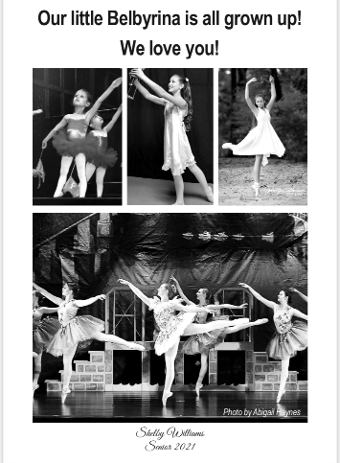
Approximate reach for each performance is 400 audience members and School Showcase has 2 performances. Programs are professionally made, and the studio can provide samples of them.
Minimum Ad Prices
Ad Size | Investment
¼ Page (4”H x 2.5”W) | $45
½ Page (4”H x 5”W) | $70
Full Page (8”H x 5”W) | $95

All ad graphics must be emailed electronically to info@chattanoogadancetheatre.com. This will produce the best quality in the program.
Attached you will find forms for both business and personal ads. All ads and payments must be turned in to Chattanooga Dance Theatre no later than May 5th. If you need more forms, please see the CDT office. Please let us know if you have any questions. As always, we appreciate your support of Chattanooga Dance Theatre.
Advertisements for
School Showcase Program 2023

Contact Person Purchasing Ad: _________________________________
Collected By (Dancer): ____________________________
Business Name if Applicable: _____________________________________________________________
Phone: ______________________________ Email: ___________________________________________

____ Full Page $95 _____ Half Page $70 _____ ¼ Page $45

Total: __________________

Please email any pictures, logo, or full ad to info@chattanoogadancetheatre.com
Type of Payment: ____ Check ____ Credit Card ____ Cash
Please make all checks payable to Chattanooga Dance Theatre.
For questions or to make a credit card payment by phone please call
Chattanooga Dance Theatre at 423-760-8808.
All ad information and payments must be turned in no later than May 5th for our May 21st performances.

