CDT’s Nooga Nutcracker 2023

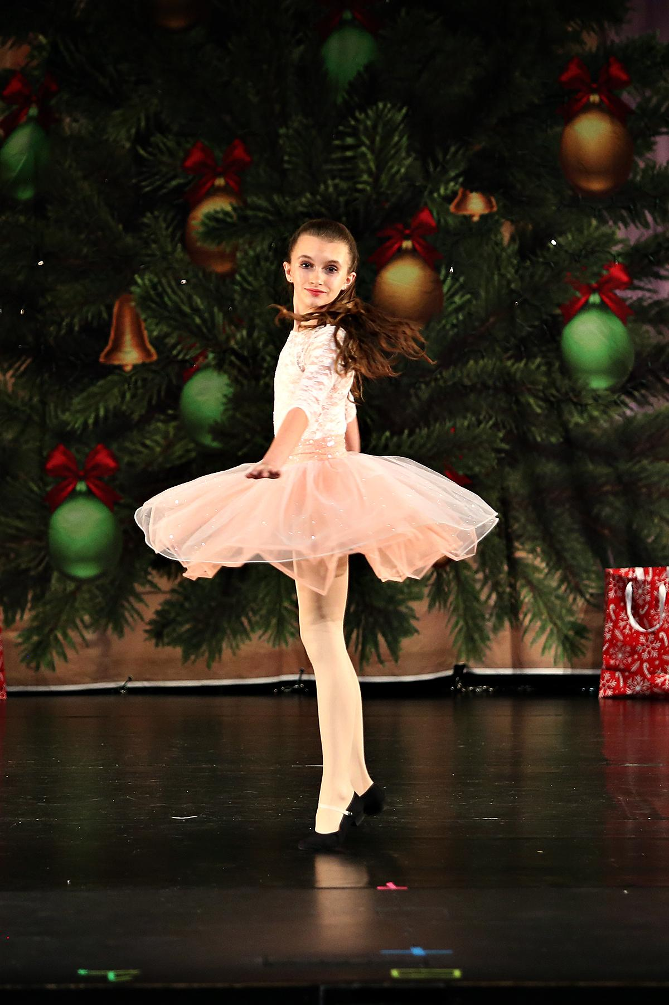

Dear dancers and parents,

We are excited to announce that CDT will be producing the 10th annual Nooga Nutcracker on Saturday, December 16th, 2023. This production is a modern twist to the traditional Nutcracker ballet, with scenes set in Chattanooga and incorporation of many forms of dance. Students and professionals will take the stage for this incredible and unique production. Both performances, 2pm and 7pm, will be held at UTC Fine Arts Center’s, Roland Hayes Auditorium. We can’t wait!

Auditions
CDT will be holding auditions for the Nooga Nutcracker on Saturday, September 9th for dancers in levels I through Advanced. Any dancer who would like to participate will need to attend an audition.

Dancers Levels VII-Advanced 10:45-12:30 (during the level VIII-Advanced class)
Dancers Levels IV-VI 1:30-2:30 pm
Dancers Levels I-III 2:45-3:30 pm

If you are unable to make it on the 9th, we can hold a separate audition in one of the classes you currently take. There is a $20 alternate audition fee for those not able to make the September 9th audition during their appropriate time. All alternate auditions must take place before the 9th as casting is made the evening of the 9th.

Important dates:
Sunday, December 3rd in the afternoon
Full Run through rehearsal Cast Red at the studio

Monday, December 11th, in the afternoon/evening
Full Run through rehearsal Cast Green at the studio

Thursday, December 14th in the afternoon/evening
Dress Rehearsal for Cast Red at UTC Fine Arts Center

Friday, December 15th in the afternoon/evening
Dress Rehearsal for Cast Green at UTC Fine Arts Center

Saturday, December 16th
Performances at 2pm(Red) and 7pm(Green). Dancers in levels I-III will need to be in their dressing rooms 30 minutes before their show. Levels IV and higher will need to arrive 1 and a half hours before show for warm up.

At the audition, each dancer (or dancer’s parent) will turn in the attached form describing times the dancer is available. We will cast and schedule rehearsals to fit as many dancers’ schedules as possible. Once cast, it is imperative that dancers attend every rehearsal every week. Dancers can expect to have about 1 hour of rehearsal weekly for 10 weeks in addition to the rehearsal and performance dates listed above. If a dancer is to miss rehearsal, please let your choreographer know as soon as possible. Dancers who miss more than two rehearsals for any part will not be able to dance in the performances. Dancers who do not participate in the dress rehearsals will not be able to dance in the performances. All dancers must be taking at least one dance class per week at CDT to perform. Class attendance of 80% is required to perform.

Investment
Students performing in Nooga Nutcracker are required to invest $160. This performance fee includes a video of the show and access to professional action photos taken during the show. (videos and photos will be available 60 days after the performance.) Performance fees also help cover choreographers, programs, costumes, sets, technical assistance during the show, and theater costs. $70 is due at the time of audition, and the remaining $90 will be charged with October tuition on October 1st. The $90 fee is waived if a parent or member of the family can assist backstage during the dress rehearsals and both performances. Because much effort is made in auditioning, casting, figuring rehearsals, and choreographing, performance fees are non-refundable and non-transferrable.

Portrait Photos
We had such great response last year from our portrait photos and are excited to bring them back this year! Portraits will be held on Sunday, November 5th. Group and individual portraits will be taken and packages will be available for viewing the studio November 8th-14th during rehearsal hours. Portrait photos are optional and a separate investment from Performance fees. More info to come!

Tickets
Tickets will go on sale two months before the show, October 16th and can be purchased through the UTC box office. Tickets prices range from $23-$34.
Q&A Sesssion
For your convenience Ms. Christine and Ms. Emily will be available on Saturday, September 2nd 12:15-1:15 at Chattanooga Dance Theatre to answer any questions you may have about Nooga Nutcracker. We will send out a zoom link if you would like to join remotely.

Casting
Dancers are cast based on talent, dedication, and needs of the performance. Casting will be posted one week after auditions, and a schedule of rehearsals will be emailed and handed out during class times. If you have any questions, do not hesitate to speak with your dance teacher or the office.

Sincerely,

Ms. Christine
Director

Ms. Emily
Performance Companies Administrator

and the CDT faculty and staff
423-760-8808

Nooga Nutcracker Audition Form 2023

Dancer’s Name: ______________________­______________­­_______­­_ Age: ______________

For Office Use Only
Audition Number: _________

Costume measurements:

Height: ______________ Bust: ______________ Waist: ______________

Hips: ________________ Girth: ______________ Inseam: ____________

What dance classes are you currently taking at CDT and other locations? (Please note you are required to stay in these classes through December 2023 to keep your parts in Nooga Nutcracker.)

____________________________________________________________________________

____________________________________________________________________________

____________________________________________________________________________

Parent(s) Name(s): ____________________________________________________________

Parent(s) Phone: ______________________________________________________________

Parent(s) Email: _______________________________________________________________

What days and times are you NOT available for rehearsal in an ordinary week?

____________________________________________________________________________

____________________________________________________________________________

Are there any specific dates you will be out of town or unable to make a rehearsal? Please list below.

____________________________________________________________________________

____________________________________________________________________________

Attendance
It is imperative that dancers who are cast attend every rehearsal every week. Dancers can expect to have about 10 one-hour rehearsals for each part cast in addition to the important dates listed below. If a dancer is to miss rehearsal, please let your choreographer know as soon as possible. Dancers who miss more than two rehearsals will not be able to dance in the performances. Dancers who do not participate in the dress rehearsals will not be able to dance in the performances. Because casting is partially based on classes the dancer is currently taking, dancers are required to take the classes listed on this form through December 2023. 80% or more class attendance is required to perform.

Important dates:
Sunday, December 3rd in the afternoon
Full Run through rehearsal Cast Red at the studio

Monday, December 11th, in the afternoon/evening
Full Run through rehearsal Cast Green at the studio

Thursday, December 14th in the afternoon/evening
Dress Rehearsal for Cast Red at UTC Fine Arts Center

Friday, December 15th in the afternoon/evening
Dress Rehearsal for Cast Green at UTC Fine Arts Center

Saturday, December 16th
Performances at 2pm(R) and 7pm(G) (call times will be earlier)

Investment
Students performing in Nooga Nutcracker are required to invest $160. This performance fee includes a video of the show and access to professional action photos taken during the show. (videos and photos will be available 60 days after the performance.) Performance fees also help cover choreographers, programs, costumes, sets, technical assistance during the show, and theatre costs. $70 is due at the time of audition, and the remaining $90 will be charged with October tuition on October 1st. The $90 fee is waived if a parent or member of the family can assist backstage during the dress rehearsals and both performances. Because much effort is made in auditioning, casting, figuring rehearsals, and choreographing, performance fees are non-refundable and non-transferrable.

Dancers are cast based on talent, dedication, availability for rehearsals, and needs of the performance. Casting will be posted the week after the auditions, and a schedule of rehearsals through December will be handed to each dancer. If you have any questions, do not hesitate to speak with the CDT staff.

I understand these requirements and if cast, will accept a role in the Nooga Nutcracker 2023, attend rehearsals regularly, and performances as cast.

Signature of Dancer: _______________________________________ Date: ______________

Signature of Parent: ________________________________________ Date: ______________

_____ Check here if one part is all you would like. (Most young and beginning dancers will only be cast in one part, but intermediate and advanced dancers may be cast in more than one if this is not checked)

_____ Check here if you would like to only be in one cast. (Many young dancers will only be in one cast, but some may be cast in both casts. Most intermediate and advanced dancers will be in both casts, unless this is checked)

